**CRM Application for Jewel Management**

**By**

**ARNAV TALAN**

[**E21CSEU0045@bennett.edu.in**](mailto:E21CSEU0045@bennett.edu.in)

**Project Abstract**

**The Jewel Inventory System is a cutting-edge Customer Relationship Management (CRM) application developed on the Salesforce platform. It is designed specifically to cater to the needs of jewellery stores and manufacturers, aiming to optimize inventory management, sales processes, and customer interactions. Through features like real-time inventory tracking, object relationship modeling, formula fields, validation rules, and automated workflows, this solution provides seamless and accurate management of jewellery items. The system empowers businesses by enhancing data accuracy, streamlining processes, and providing actionable insights through reports and dashboards.**

**INTRODUCTION**

**Managing inventory and sales in a jewellery business involves unique challenges, such as handling valuable items, tracking stock levels, and managing customer relationships. To address these needs, the Jewel Inventory System, built on Salesforce, offers a robust and intuitive CRM solution tailored for the jewellery industry.**

**The application enables users to efficiently manage jewellery stock, track sales transactions, and customize their interface to meet specific business needs. With features such as data modeling, object relationships, formula fields, validation rules, and automated workflows, the system ensures data accuracy and operational efficiency. The application also integrates powerful reporting and dashboard functionalities, enabling store owners and managers to monitor business performance and make informed decisions.**

**By leveraging the versatility of Salesforce, the Jewel Inventory System provides a comprehensive solution to optimize business operations, reduce manual effort, and improve overall productivity in the jewellery sector.**

**Task 1:**

**Creating Developer Account and Account Activation.**

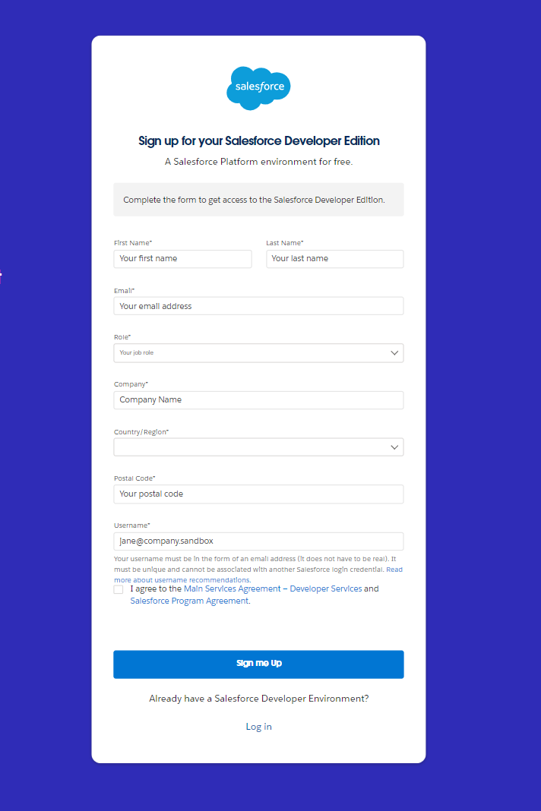

Task 2:

**Create Jewel Customer Object:**

**The purpose of creating a Jewel Customer custom object is to store and manage information about Customer.**

**To create an object:**

1. **From the setup page  >> Click on Object Manager  >> Click on Create  >> Click on Custom Object.   
   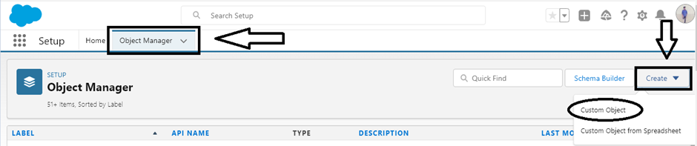**
2. **Enter the label name >> Jewel Customer**
3. **Plural label name >> Jewel Customers**

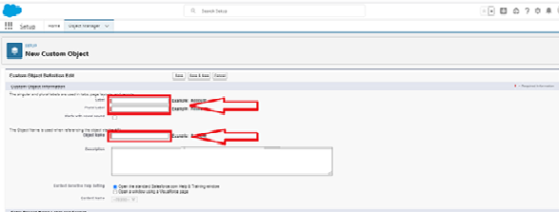

1. **Enter Record Name Label and Format**

* **Record Name  -->  Customer name**
* **Data Type  -->  Text**

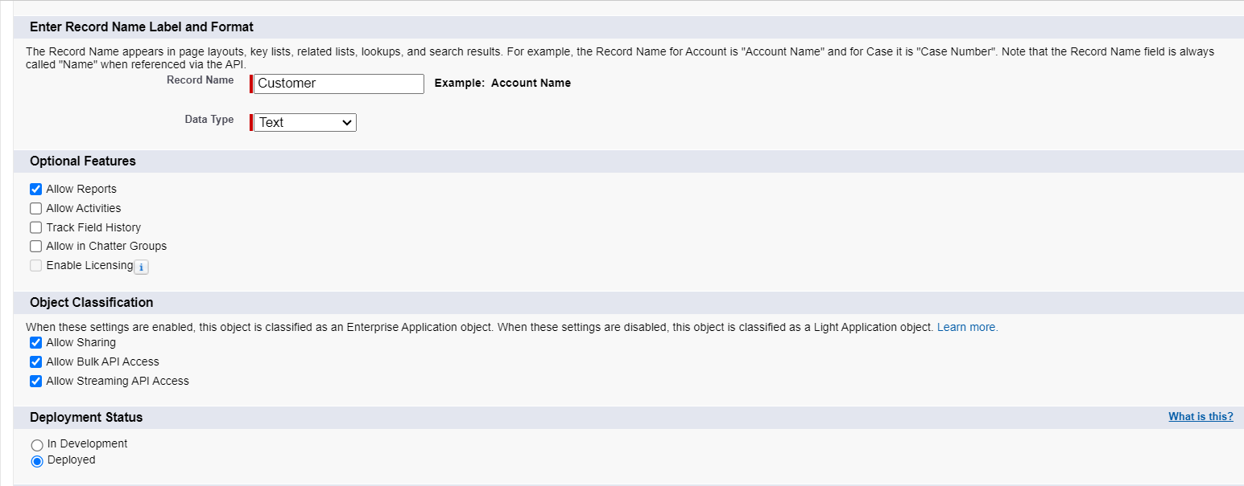

1. **Click on Allow reports.**
2. **Allow search  --> Save.**

**Task 3:**

**Create Item Object**

**The purpose of creating a Item object is to manage the inventory of gold and silver items.**

**To create an object:**

1. **From the setup page   >> Click on Object Manager  >>  Click on Create  >>  Click on Custom Object.**
2. **Enter the label name >> Item**
3. **Plural label name >>  Items**
4. **Enter Record Name Label and Format**

* **Record Name  >>  Item Id**
* **Data Type >> Auto Number**
* **Display Format >> Item-{00}**
* **Starting Number >> 1**

1. **Click on Allow reports.**
2. **Allow search >> Save.**

**Task 4:**

**Creating a Custom Tab**

**To create a Tab:(Customer)**

1. **Go to setup page >> type Tabs in Quick Find bar >> click on tabs >> New (under custom object tab)   
   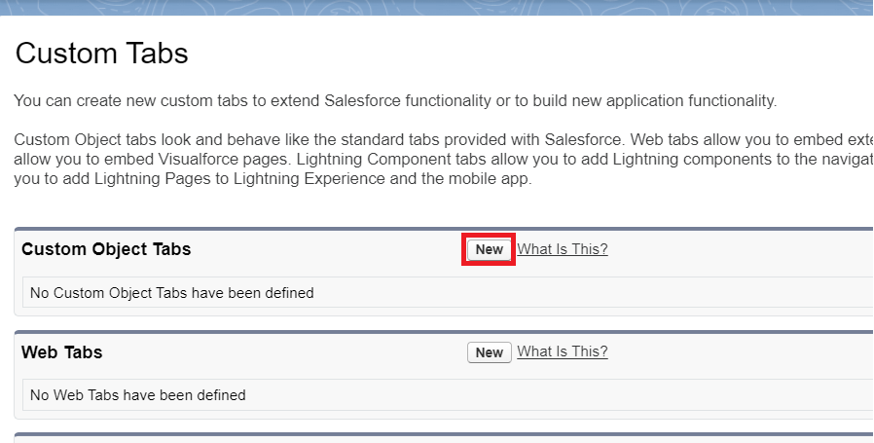**
2. **Select Object(Jewel Customer) >> Select any tab style >> Next (Add to profiles page) keep it as default >> Next (Add to Custom App) keep it as default >> Save.**

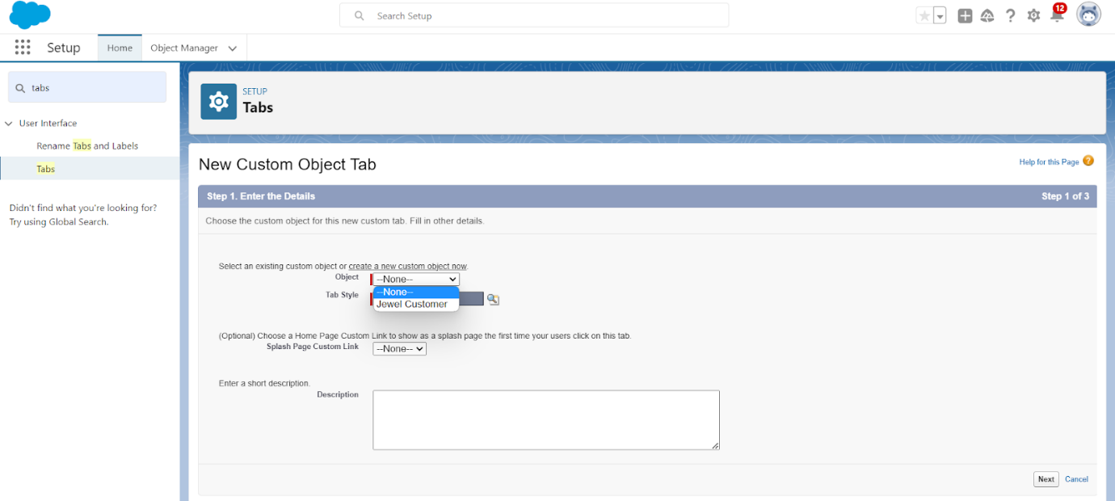

**Task 5:**

**Create a Lightning App**

**To create a lightning app page:**

1. **Go to setup page>>search “app manager” in quick find>>select “app manager”>>click on New lightning App.  
   A screenshot of a computer

   Description automatically generated**
2. **Fill the app name in app details and branding as follow  
   App Name : Jewellery Inventory System.  
   Developer Name : This will auto populated  
   Description : Elevate your look with elegance  
   Image : optional (if you want to give any image you can otherwise not mandatory)  
   Primary colour hex value : keep this default.  
   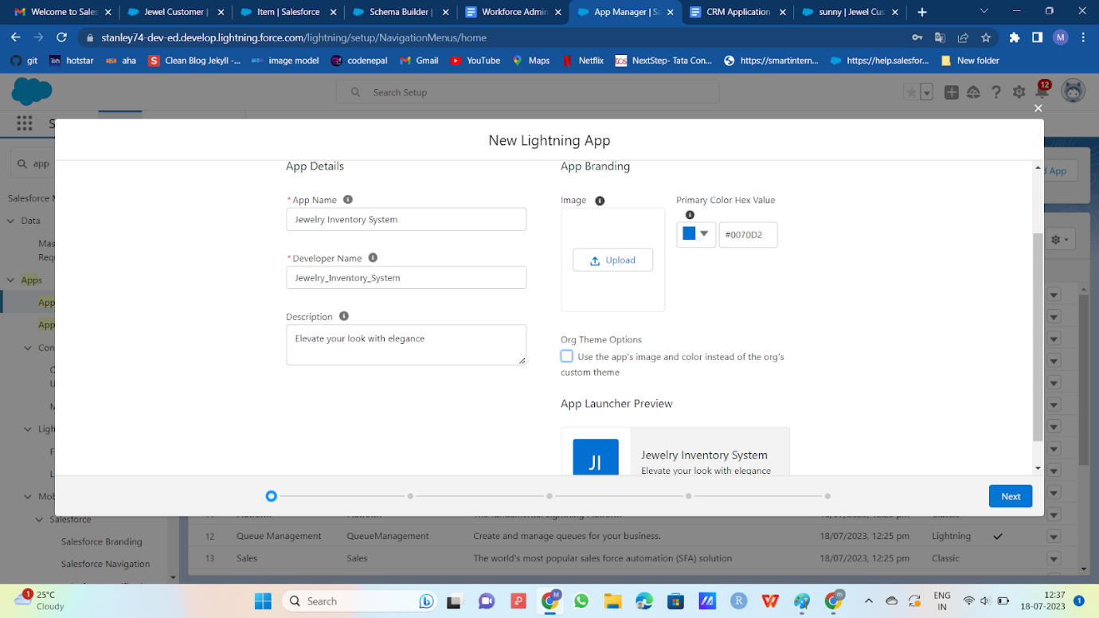**
3. **Then click Next >>(App option page)Set Navigation Style as Console Navigation>>Next.  
   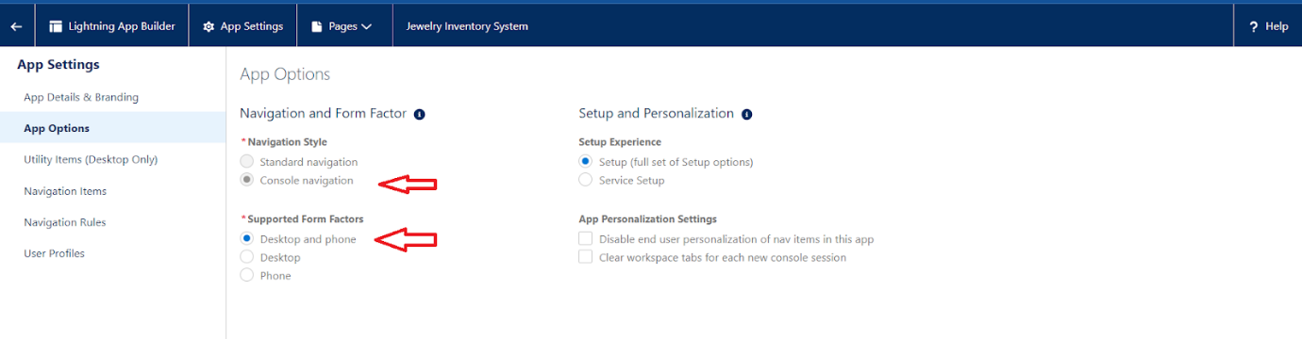**
4. **(Utility Items) keep it as default>>Next.**
5. **To Add Navigation Items:  
   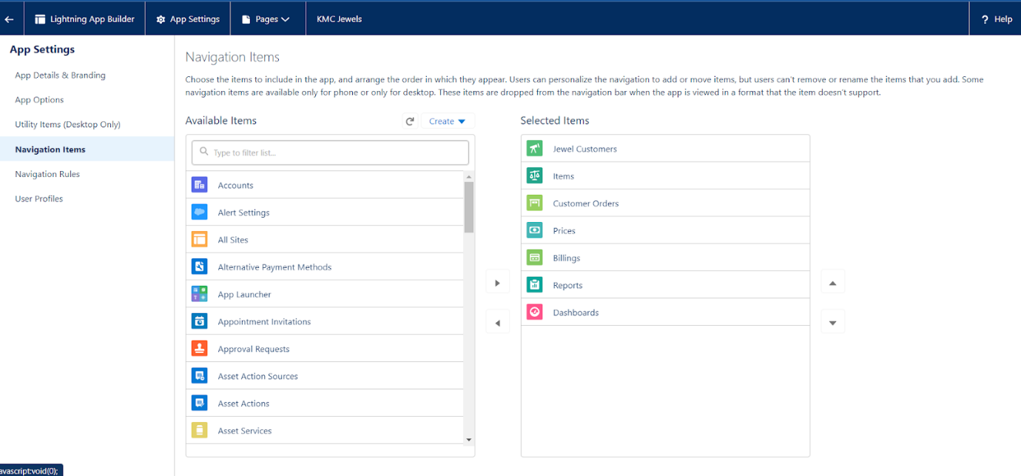  
   Search for the item in the (JewelCustomer,Item,CustomerOrder,Price,Billing,Reports, Dashboard) from the search bar and move it using the arrow button>>Next>>Next.**
6. **To Add User Profiles:**

**Search profiles (System administrator) in the search bar>>click on the arrow button>>save & finish.**

**Task 6:**

**To Create a relationship between Jewel Customer & Customer Order Objects.**

1. **Go to the setup page >> click on object manager >> type object name(Customer Order) in the quick find bar >> click on the object.**
2. **Click on fields & relationship >> click on New.**
3. **Select “Lookup relationship” as data type and click Next.**
4. **Select the related object “ Jewel Customer ”.**
5. **Give Field Label as “Customer” and click Next.**
6. **Next >> Next >> Save.**

**Task 7:**

**Creating Master-Detail Relationship between Item & Customer Order Object.**

**To Create a Master-Detail relationship :**

**1. Go to the setup page >> click on object manager >>  type object name(Customer Order) in the quick find bar >> click on the object.**

**2.Click on fields & relationships >> click on New.**

**3.Select “Master-Detail relationship” as data type and click Next.**

**4.Select the related object “ Item”.**

**5.Give Field Label as “Item” and click Next.**

**6.Next >> Next >> Save.**

**Task 8:**

**Creating Text Field in Jewel Customer Object**

**To create fields in an object:**

1. **Go to setup >>click on Object Manager>> type object name(Jewel Customer ) in quick find bar>> click on the object.  
   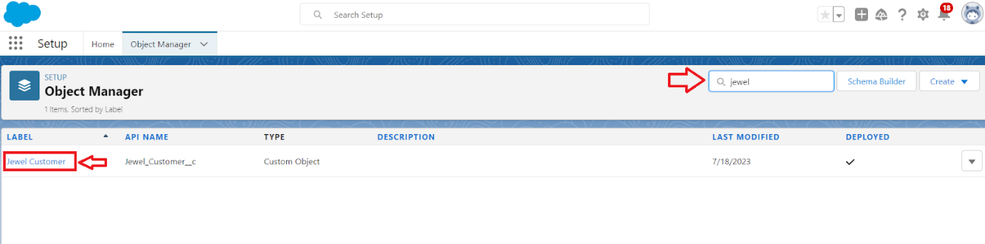**
2. **Now click on “Fields & Relationships” ? New  
   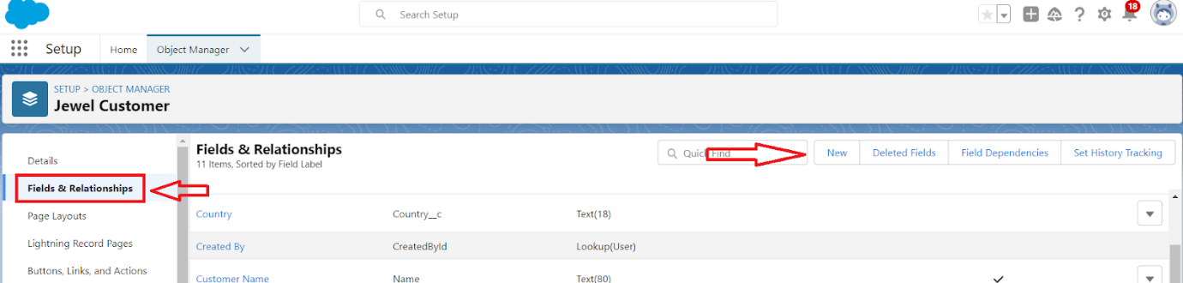**
3. **Select Data type as “Text”.  
   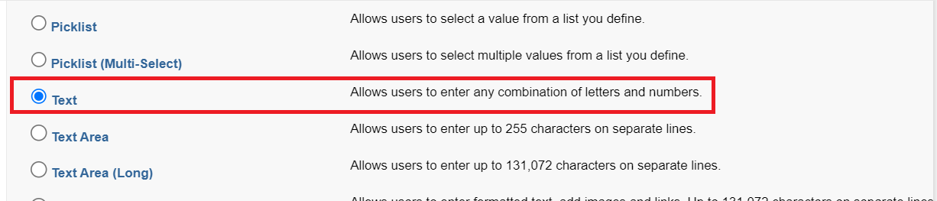**
4. **Click on Next  
   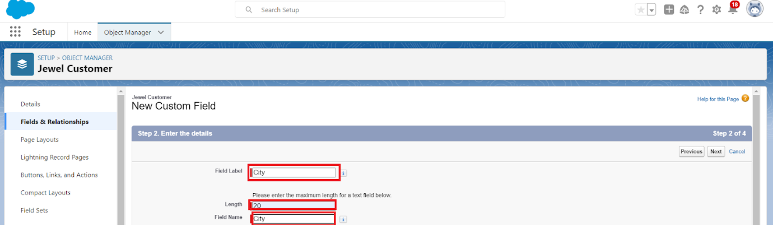**
5. **Fill the above as following:**

* **Field Label: City**
* **Length : 20**
* **Field Name : gets auto generated**
* **Click on Next >> Next >> Save and new.**

**Task 9:**

**Creating Schema Builder**

1. **Go to setup >> click on Object Manager >> Schema Builder.**
2. **Select objects >> Enter Objects as “Jewel Customer,Item,Customer Order, Price, Billing objects” in quick box and select them.**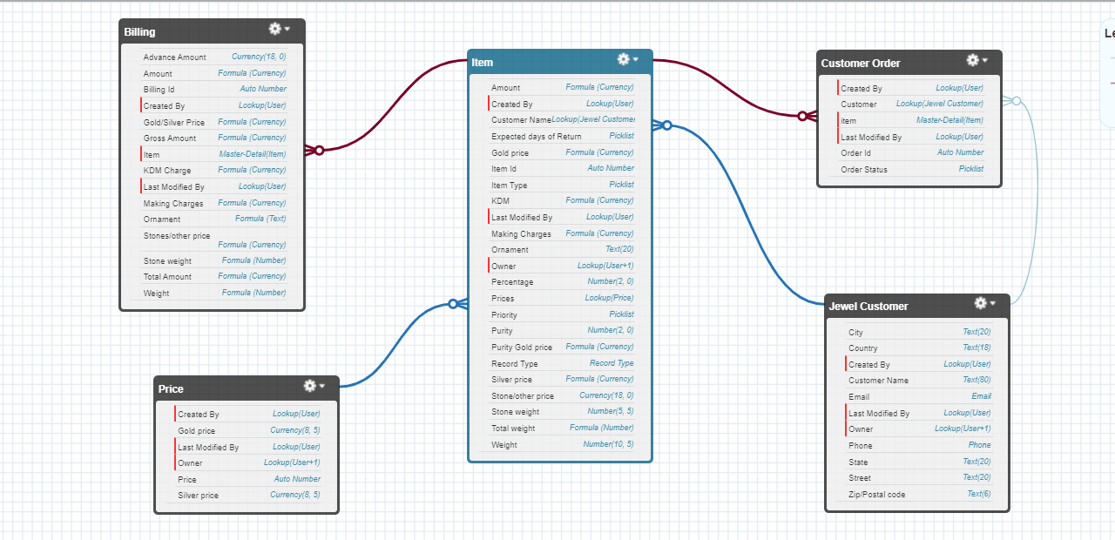

**Task 10:**

**Creating the Field Dependencies**

1. **Go to setup >> click on Object Manager >> type object name(Item) in quick find bar >>click on the object.**
2. **Click on Fields & Relationships and click on the Priority field.**
3. **Search for Field Dependencies and click on New.**

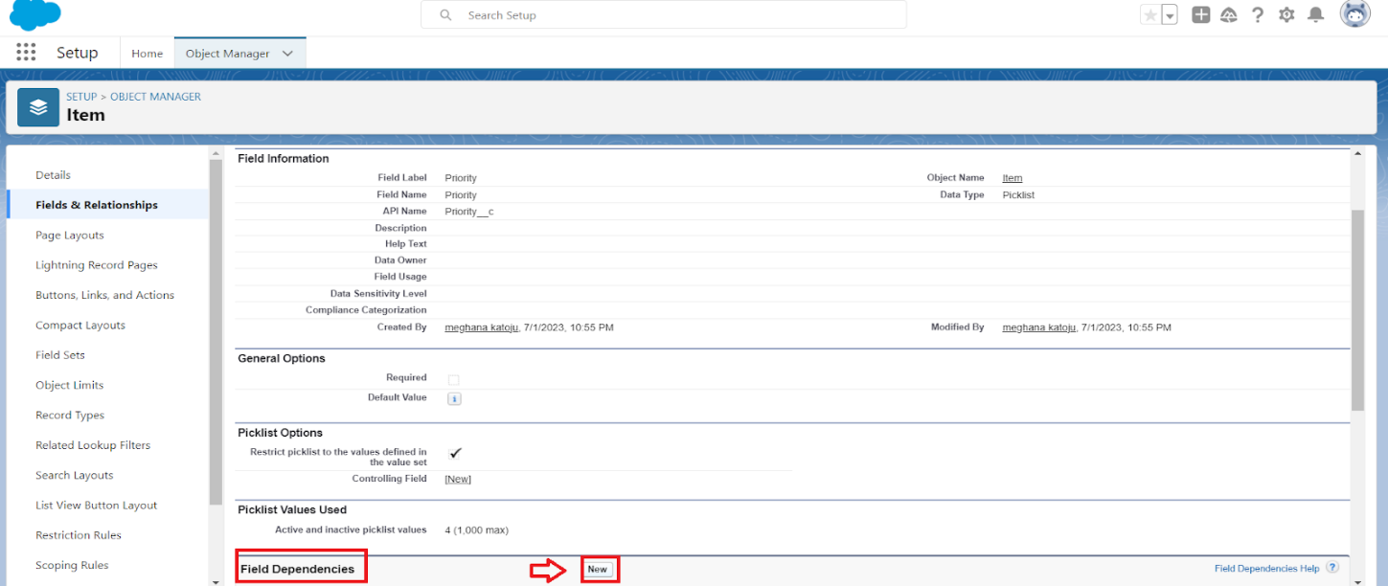

1. **Select Controlling Field as “Priority” and Depending field as “Expected Days of Return”>>Continue.**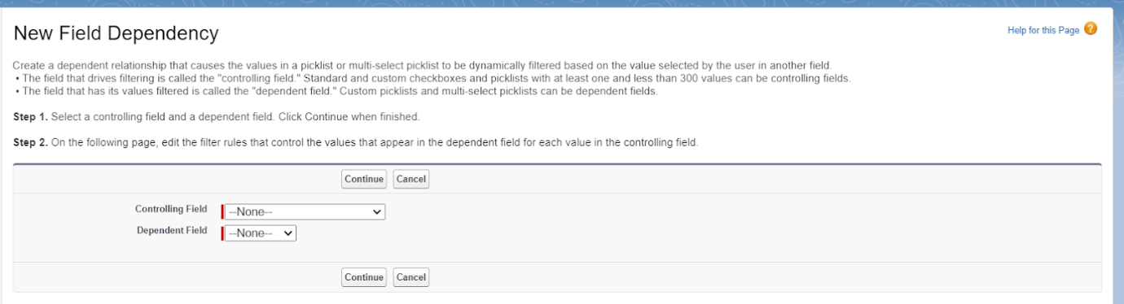

1. **Select the “Expected Days of Return” values of related Priority values and Click on Include Values >> Save.**

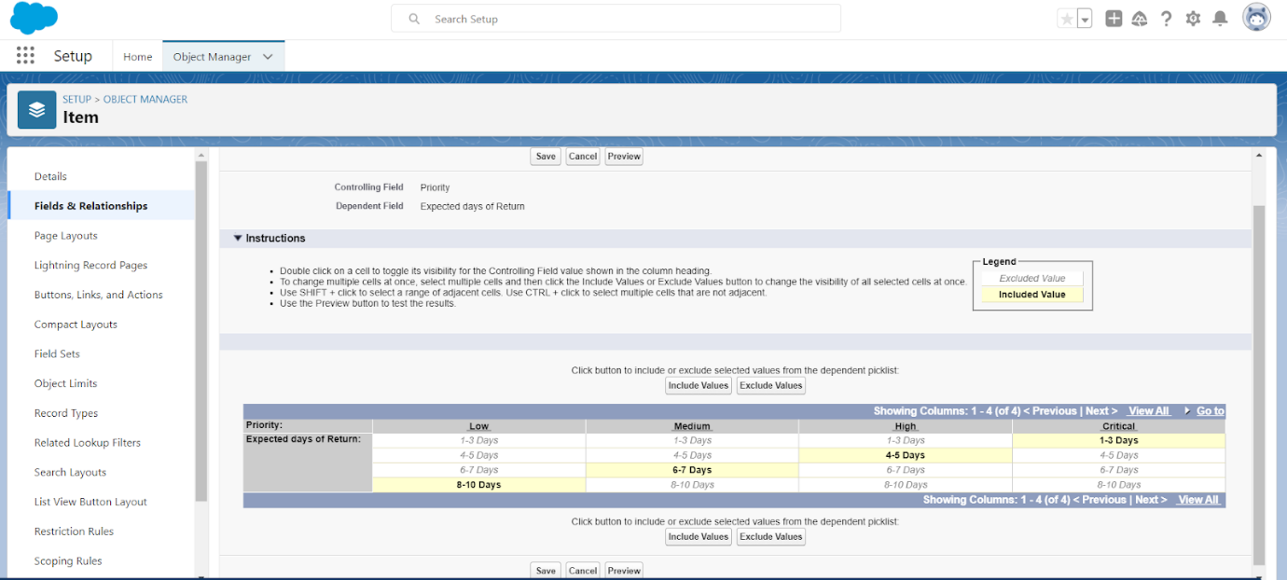

**Task 11:**

**Creating the validation rule**

1. **Go to setup >> click on Object Manager >> type object name(Jewel Customer ) in quick find bar >> click on the object.**
2. **Click on the validation rule >> click New.A screenshot of a computer

   Description automatically generated**
3. **Enter the Rule name as “Postal Code “.**
4. **Insert the Error Condition Formula as : -**

**AND(**

**OR(**

**LEN( Zip_Postal_code__c ) <> 6,**

**NOT(REGEX(Zip_Postal_code__c, "^[0-9]{6}$"))**

**),**

**NOT(ISBLANK(Zip_Postal_code__c))**

**)**

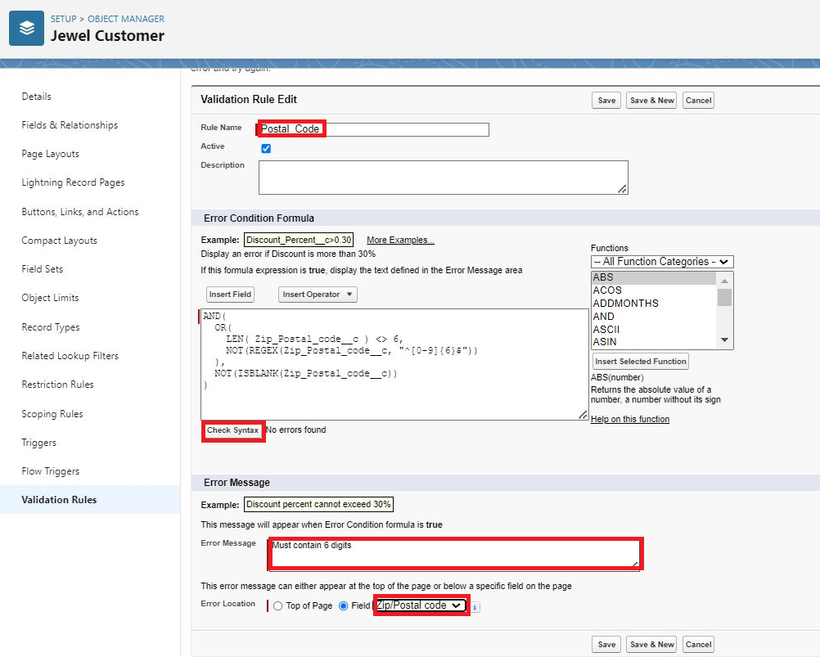

1. **Enter the Error Message as “Must contain 6 digits”, select the Error location as Field and select the field as “Zip/Postal code”, and click Save.**

**NOTE:**

**Create One more Validation rule for Jewel Customer object.**

1. **Enter Rule name as “ValidationRule For JewelCustomerObject “.**
2. **Insert the Error Condition Formula as : -**

**OR( ISBLANK( City__c ) , ISBLANK( Country__c ),ISBLANK( Phone__c ),ISBLANK( State__c ),ISBLANK(     Street__c ) )**

1. **Enter the Error Message as “Please fill Required fields”, select the Error location as Top of Page and click Save.**

**Create Validation rule for Item object.**

1. **Enter Rule name as “ValidationRule For Item“.**
2. **Insert the Error Condition Formula as : - OR( ISBLANK(  Amount__c  ) , ISBLANK(  Customer_Name__c  ) ,ISBLANK( Gold_price__c ),ISBLANK( KDM__c ),ISBLANK( Ornament__c ),ISBLANK( Percentage__c ),ISBLANK( Making_Charges__c ),ISBLANK( Prices__c ),ISBLANK( Stone_weight__c ),ISBLANK( Silver_price__c ),ISBLANK( Stone_other_price__c ),ISBLANK( Stone_weight__c ),ISBLANK( Weight__c ))**
3. **Enter the Error Message as “Please fill Required fields”, select the Error location as Top of Page and click Save.**

**Task 12:**

**Gold Smith Profile**

**To create a new profile:**

1. **Go to setup >> type profiles in quick find box >> click on profiles >> clone the desired profile (System Administrator) >> enter profile name (Gold Smith) >> Save.**

1. **While still on the profile page, then click Edit.**
2. **Scroll down to Custom Object Permissions and Give access permissions for Jewel Customer,Item,Customer Order,Prices,Billings .**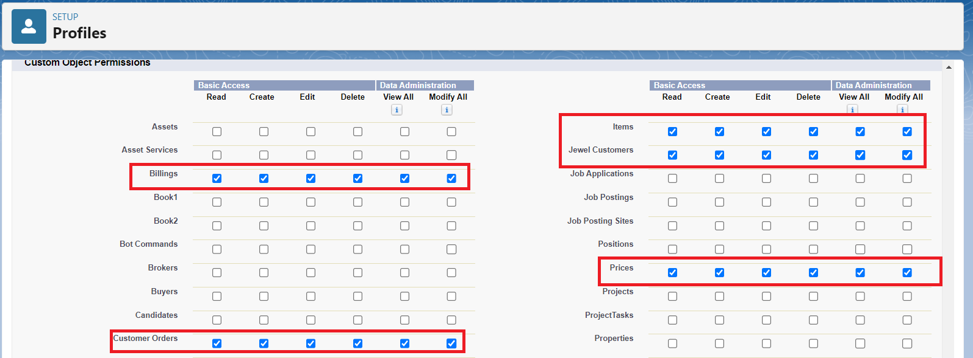
3. **Scroll down and Click on Save.**
4. **Follow all the steps for creating worker profile.**

**Task 13:**

**Creating Gold Smith Role**

1. **From setup >> Go to quick find >> Search for Roles >> click on set up roles.**

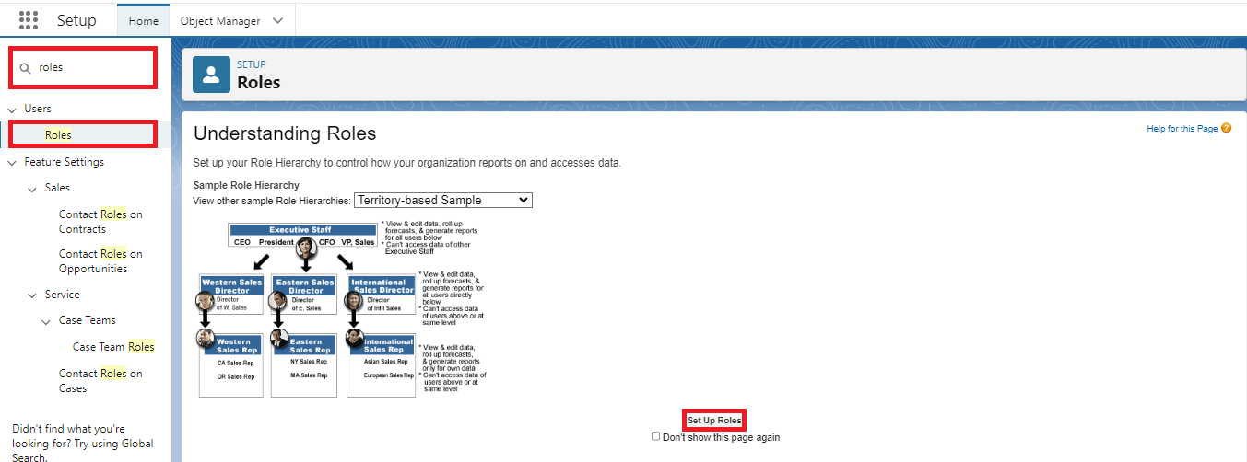

1. **Click on Expand All and click on add role under whom this role works.**

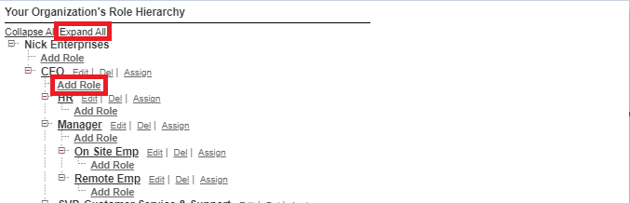

1. **Give Label as “Gold Smith” and Role name gets auto populated. Check to whom this role (Gold Smith) reports. Then click on Save.**

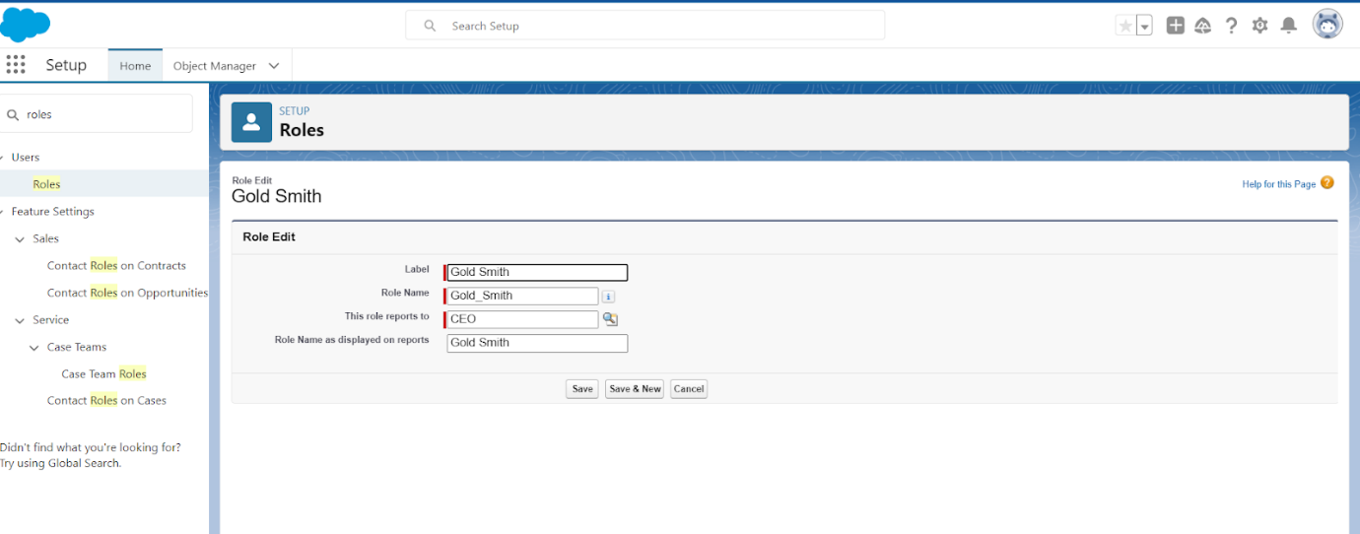

**Note:**

**Create one more role as Worker  which reports to Gold Smith.**

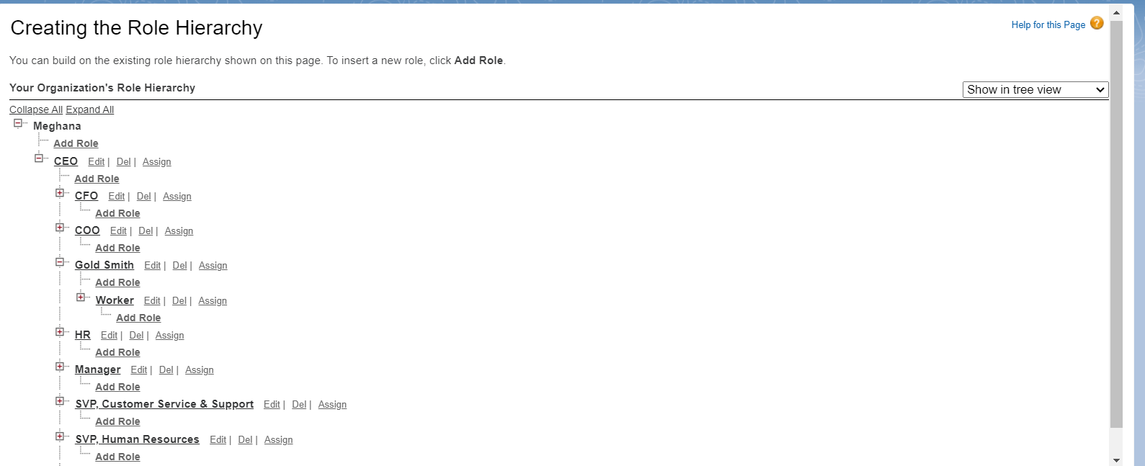

**Task 14:**

**Create User**

1. **Go to setup >> type users in quick find box >> select users >> click New user.**
2. **Fill in the fields**
3. **First Name : Niklaus**
4. **Last Name : Mikaelson**
5. **Alias : Give a Alias Name**
6. **Email id : Give your Personal Email id**
7. **Username : Username should be in this form: text@text.text**
8. **Nick Name : Give a Nickname**
9. **Role : Gold Smith**
10. **User licence : Salesforce**
11. **Profiles : Gold Smith**

1. **Save.**

**Task 15:**

**To Create a Gold and Silver Page layout**

1. **Go to Setup >> Click on Object Manager >> Search for the object (Item) >> From drop down click on Edit.**
2. **Click on Page layout >> Click on New.**

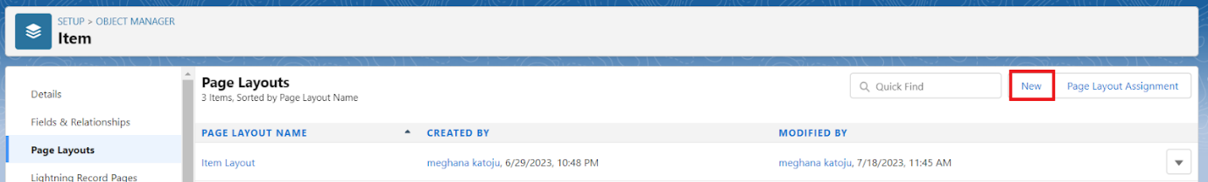

1. **Give Page layout Name as “Page Layout for Gold” and click on Save.**

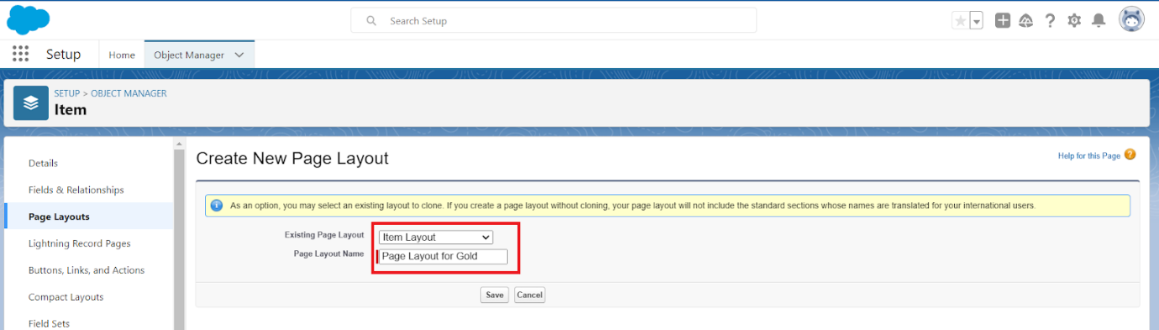

1. **Arrange the field as shown in the Information Section ,remove fields which are related to Silver and click Ok.**

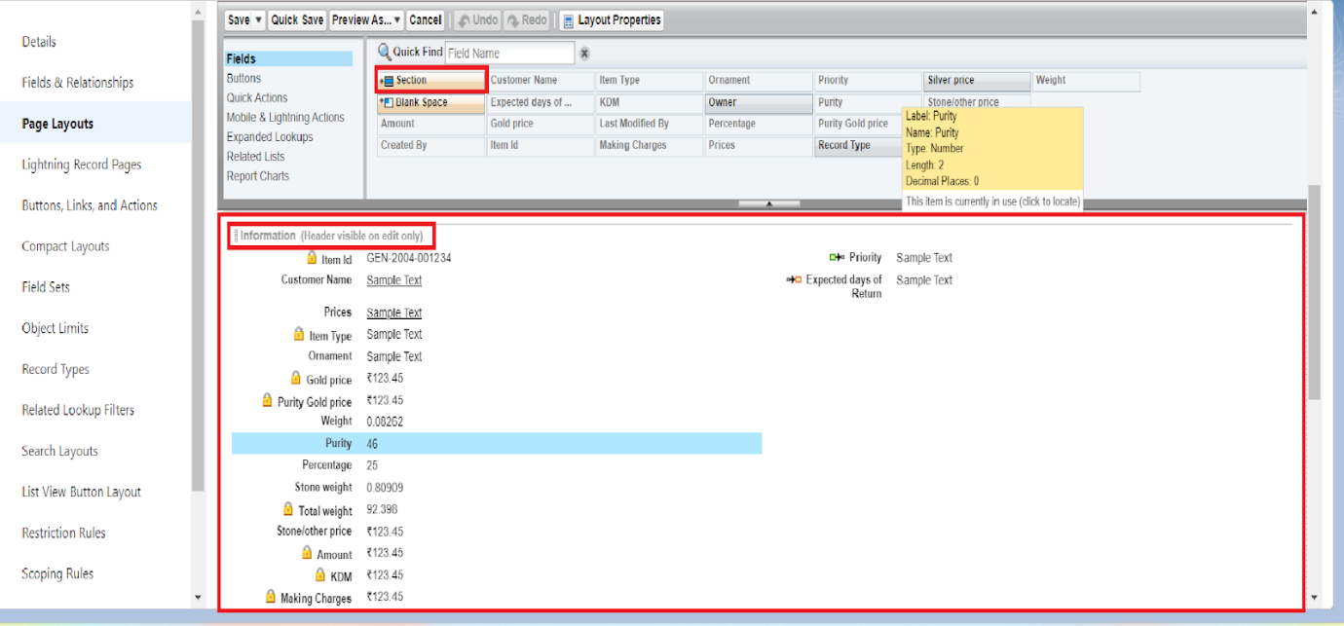

1. **Click Save.**
2. **Make sure your page layout looks like the picture above.**

**Task 16:**

**create a Record Type**

1. **Go to setup >> click on Object Manager >> type object name(Item) in quick find bar >> click on the object.**
2. **Click on the Record Types >> click New.**

1. **Select Existing Record as “Master”,Record type Label as “Gold”,Description as “Gold items information”.**

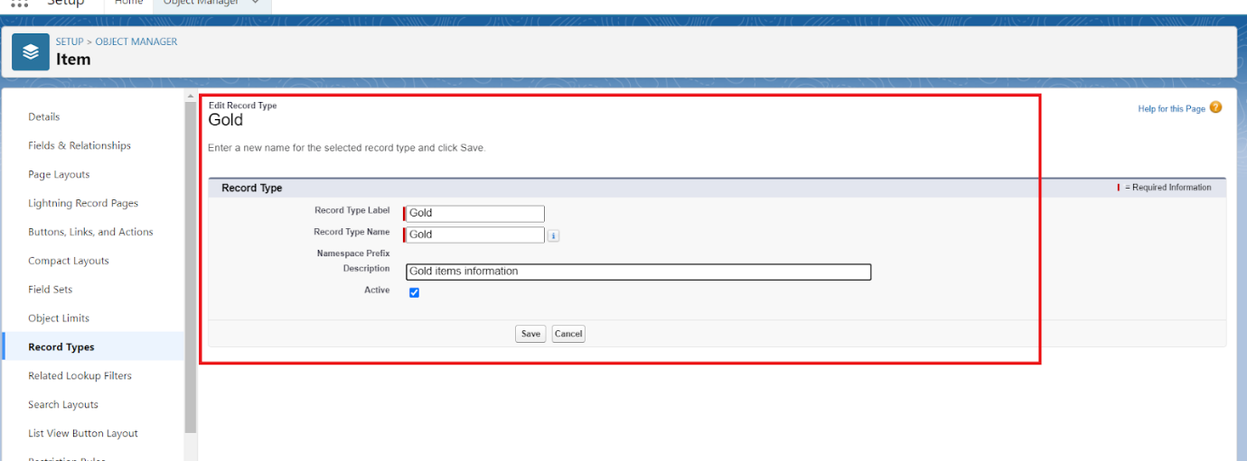

1. **Uncheck for “Make Available”.  
   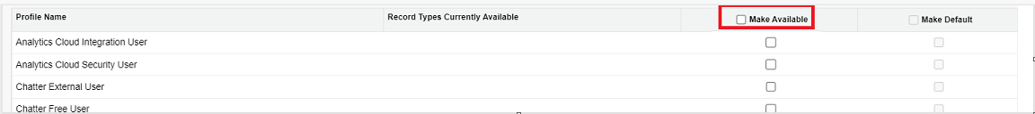**
2. **Scroll  down and check for the Gold Smith,Worker & System Administrator profile and click on Next.**
3. **Select “Apply a different layout for each profile”, and change page layout to “Page Layout for Gold“for Gold Smith,Worker and System Administrator >> save & new.**

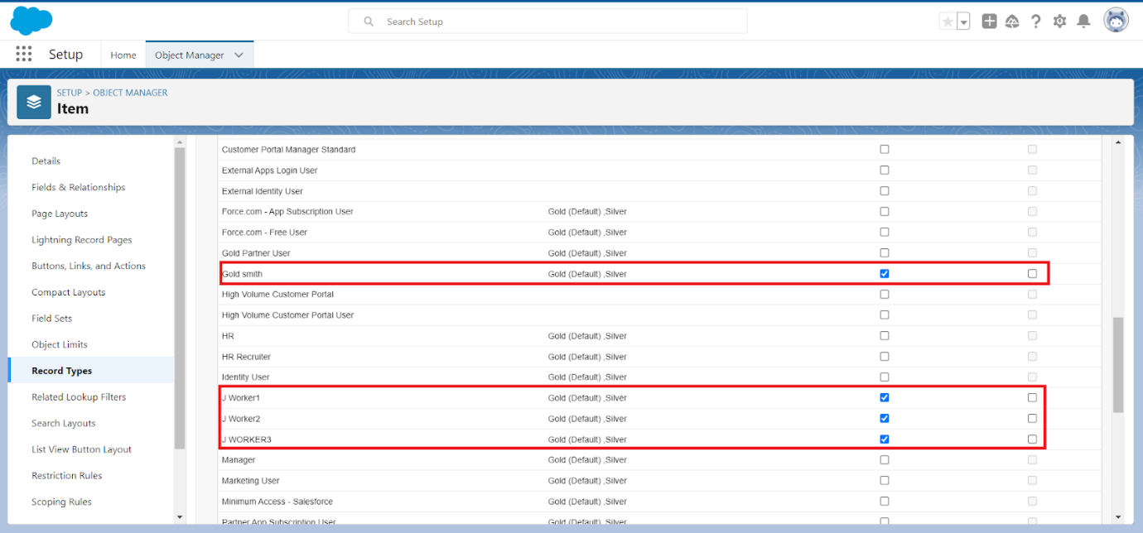

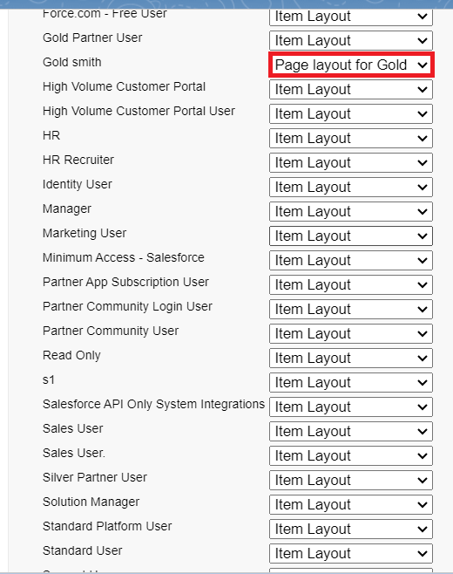

**Note:Create another Record Type with name “Silver” following the steps from Activity1( Use page layout for Silver).**

**Task 17:**

**Creating permission set**

1. **Go to setup >> type “permission sets” in quick search >> select permission sets >> New.**

1. **Enter the label name as “Per to Worker”, API will be auto populated >> save.**

1. **Under Apps Select object settings.**

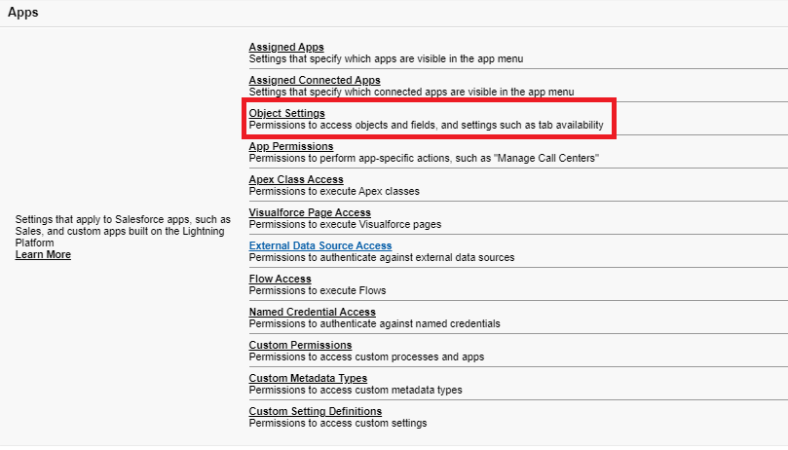

1. **Click on Items object  >> click on Edit >> under Item:Record Type Assignments,enable Gold,Silver  >> Object permission check for read ,edit and create.**

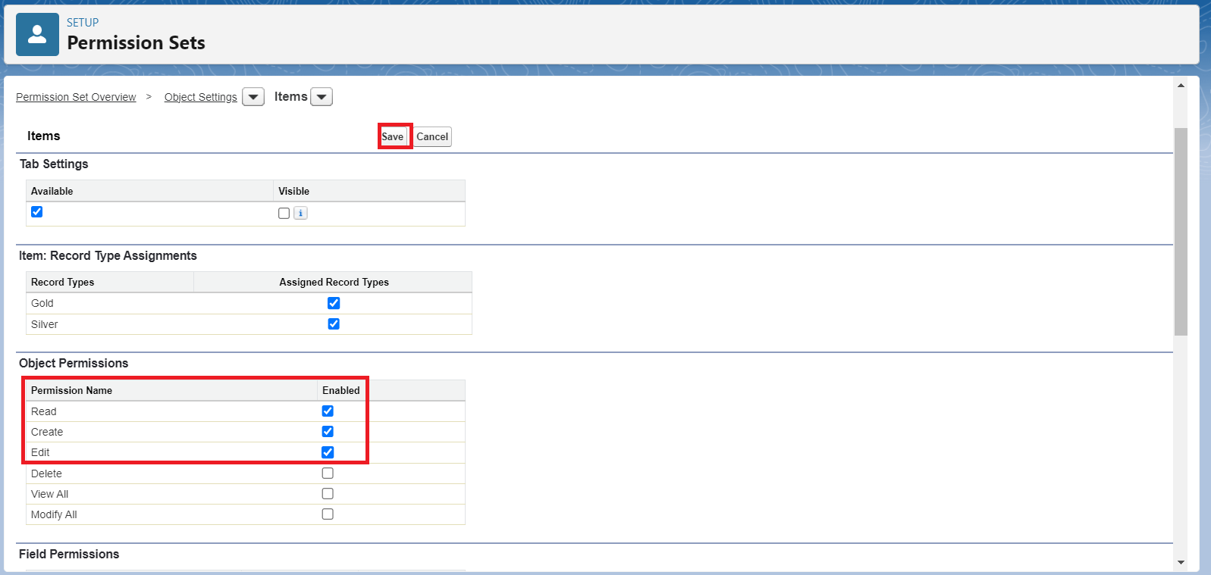

1. **Click on Save.**
2. **After saving the permission click on the Manage assignment**
3. **Now click on the Add Assignment.**



1. **Now select the users which you have created in user milestone, using  Worker profile and click on Next >> Assign >> Done.**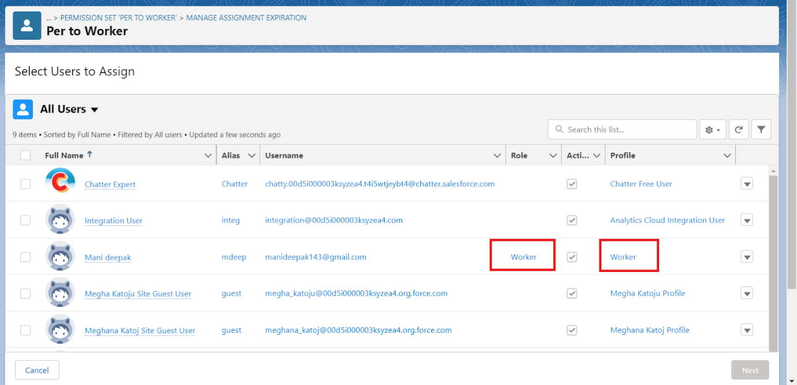

**Task 18:**

**Create a Record (Jewel Customer)**

1. **Click on App Launcher on the left side of the screen.**
2. **Search Jewelry Inventory System & click on it.**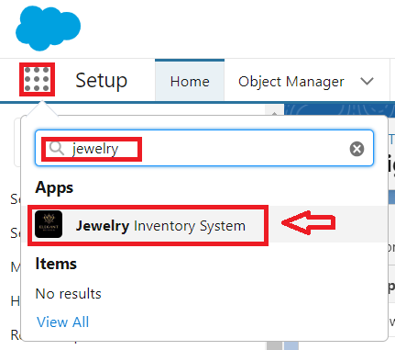
3. **Click on Drop Down and Click on the Jewel Customer tab.**
4. **Click  New**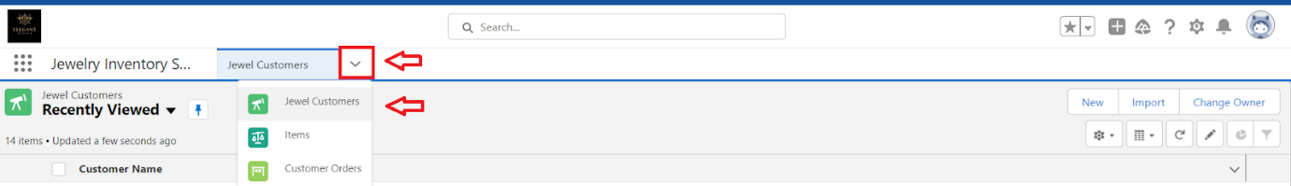
5. **Fill the details and click on save.**

**Task 19:**

**Create Report**

1. **Go to the app >> click on the reports tab.**
2. **Click New Report.**

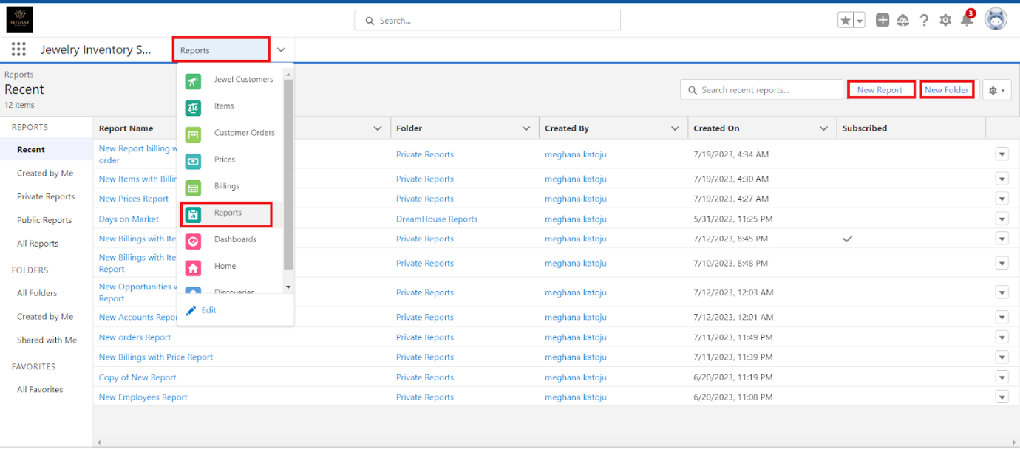

1. **Select report type from category or from report type panel or from search panel ? click on start report**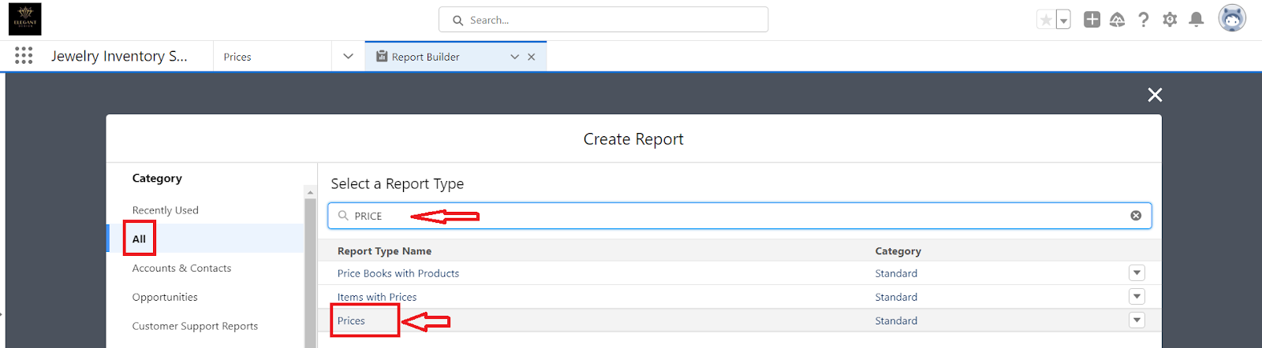
2. **Customise your report**
3. **Add fields from the left pane as shown below.**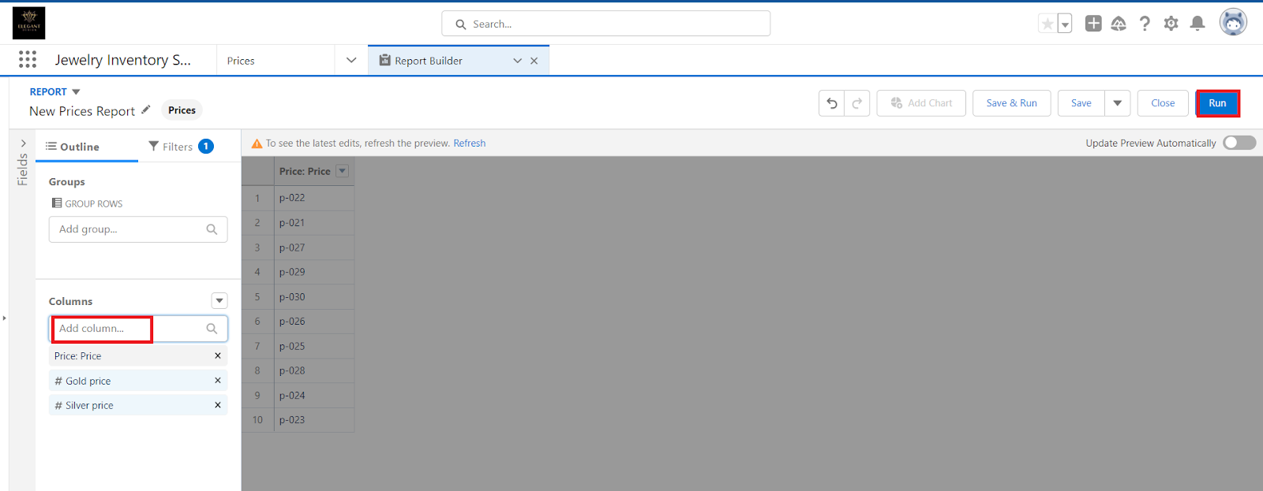

1. **Save or run it.**

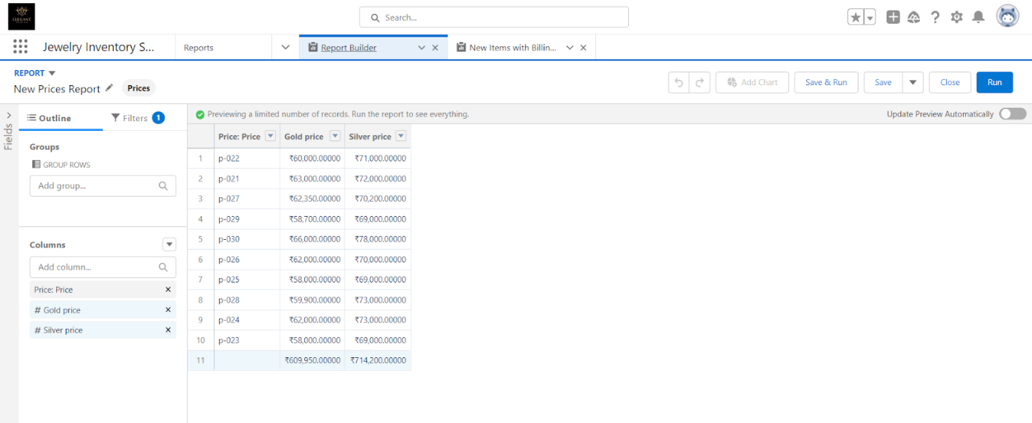

**Note: Reports may get varied from the above pictures as the data might be different.**

**Task 20:**

**Creating Dashboards**

**Go to the app>>click on the Dashboards tabs.**

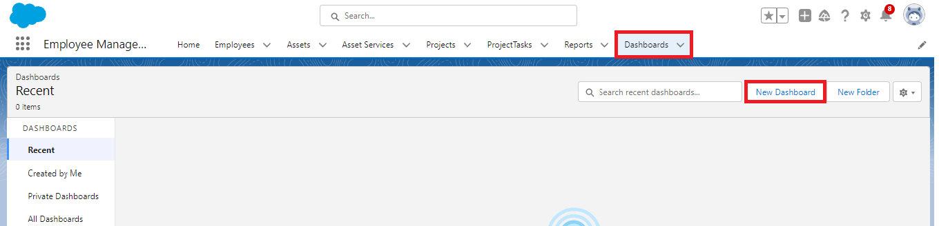

1. **Give a Name and click on Create.**

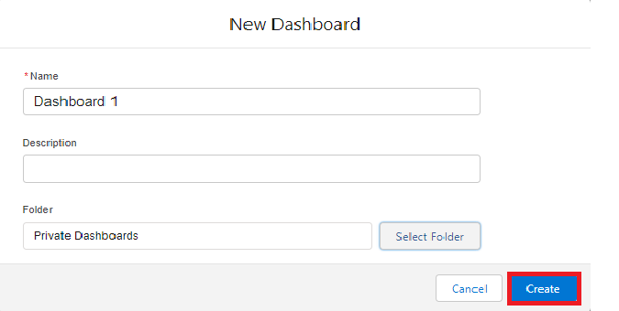

1. **Select add component.**



1. **Select a Report and click on select.**

1. **Click Add then click on Save and then click on Done.**

**Note:Create another Dashboard as we discussed in activity 1.**

**Task 21:**

**Create a Flow**

1. **Go to setup >> type Flow in quick find box >> Click on the Flow and Select the New Flow.**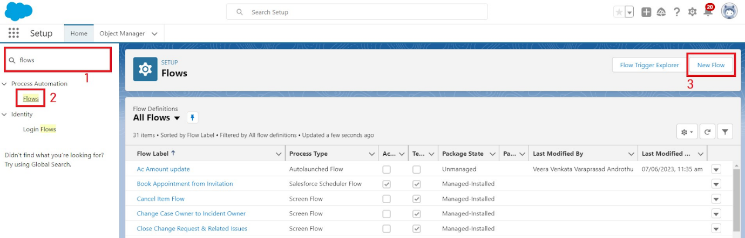
2. **Select the Record-triggered flow and Click on Create.**

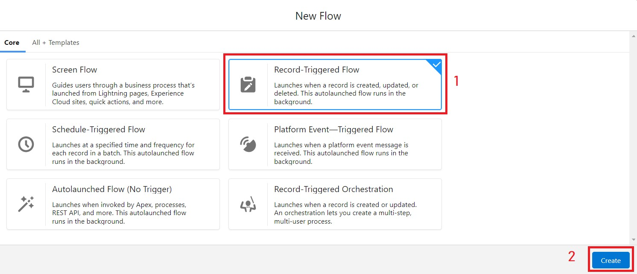

1. **Select the Object as a “Billing” in the Drop down list.**
2. **Select the Trigger Flow when: “A record is Created or Updated”.**
3. **Select the Optimize the flow for: “Actions and Related Records” and Click on Done.**
4. **Now change the mode form Auto-layout to free-form.**
5. **Now select the manger option in the toolbox, click New resource.A screenshot of a computer

   Description automatically generated**
6. **Select the resource type as text template.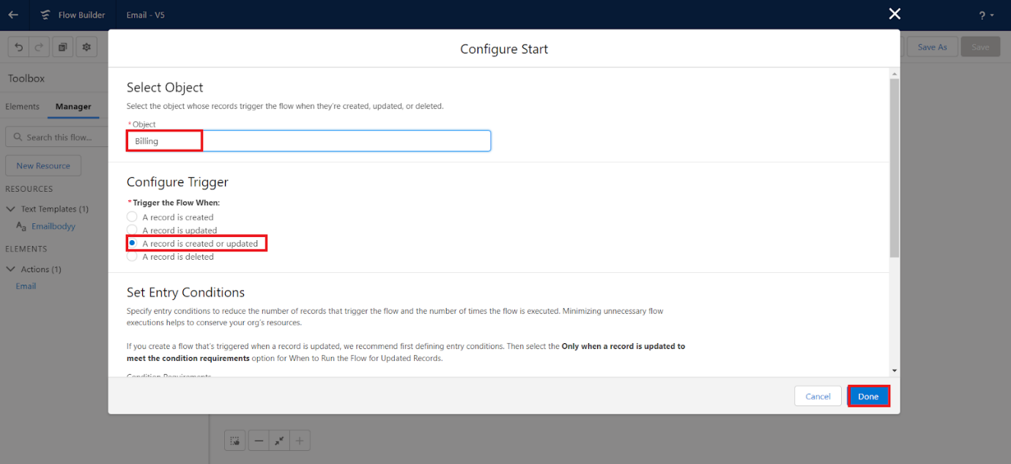A screenshot of a computer

   Description automatically generated**
7. **Enter the API name as “ Email body”.**

1. **Change the view as Rich Text>>View to Plain Text.**
2. **In the body field  paste the syntax that is given below.**

**Hello**

**Customer Name: {!$Record.Item__r.Customer_Name__r.Name}**

**Here are the details for the item you purchased with Jewelry Inventory System**

**Item Type: {!$Record.Item__r.Item_Type__c}**

**Ornament: {!$Record.Ornament__c}**

**Weight: {!$Record.Weight__c}grams**

**Amount: {!$Record.Amount__c}**

1. **Click done.**
2. **Now click on elements, and drag the action element into the preview pane.**
3. **Their action bar will be opened in that search for “ send email ” and click on it.**
4. **Give the label name as “ notice”**
5. **API name will be auto populated.**
6. **Enable the body in set input values for the selected action.**
7. **Select the text template that was created.**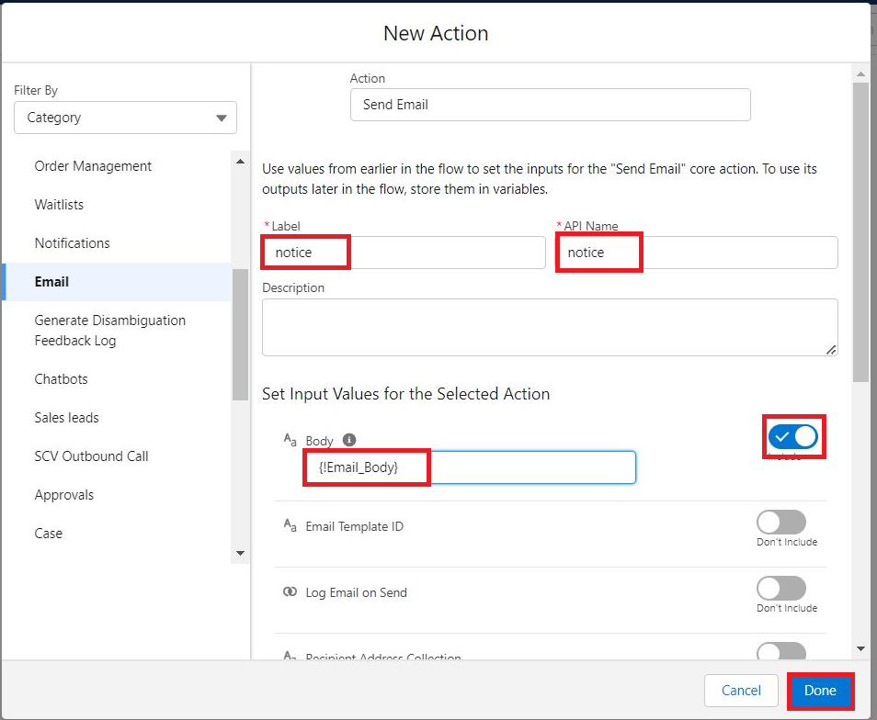
8. **Include Recipient Address list, select the email form the record.**

**({!$Record.Item_r.Customer_Namer.Email_c})**

1. **Include the subject as “Welcome to Jewelry Inventory System ”.**
2. **Click done.A screenshot of a computer

   Description automatically generated**
3. **Now drag the path from the start to the action element.**
4. **Click on save. Given the Flow label  , Flow Api name will be auto populated.**
5. **And click save, and click on activate.A screenshot of a computer

   Description automatically generated**